ASSIGNMENT 5

To create c++ programs for the different scheduling algorithms.

## First Come First Serve (FCFS) Scheduling

## Algorithm Overview

FCFS is a non-preemptive scheduling algorithm where processes are executed in the order of their arrival. The process that arrives first is allocated the CPU first. Key metrics include:

**Waiting Time (WT):** Time a process waits in the ready queue.

**Turnaround Time (TAT):** Total time from arrival to completion (WT + Burst Time).

#include <iostream>

#include <vector>

#include <algorithm>

using namespace std;

struct Process {

int id;

int arrivalTime;

int burstTime;

int waitingTime;

int turnaroundTime;

};

void calculateTimes(vector<Process>& processes) {

processes[0].waitingTime = 0;

int currentTime = processes[0].arrivalTime + processes[0].burstTime;

for (size_t i = 1; i < processes.size(); ++i) {

processes[i].waitingTime = max(currentTime - processes[i].arrivalTime, 0);

currentTime += processes[i].burstTime;

processes[i].turnaroundTime = processes[i].waitingTime + processes[i].burstTime;

}

}

int main() {

int n;

cout << "Enter number of processes: ";

cin >> n;

vector<Process> processes(n);

for (int i = 0; i < n; ++i) {

processes[i].id = i + 1;

cout << "Enter arrival and burst time for P" << processes[i].id << ": ";

cin >> processes[i].arrivalTime >> processes[i].burstTime;

}

sort(processes.begin(), processes.end(), [](const Process& a, const Process& b) {

return a.arrivalTime < b.arrivalTime;

});

calculateTimes(processes);

cout << "\nProcess\tArrival\tBurst\tWaiting\tTurnaround\n";

for (const auto& p : processes) {

cout << "P" << p.id << "\t" << p.arrivalTime << "\t" << p.burstTime

<< "\t" << p.waitingTime << "\t" << p.turnaroundTime << endl;

}

return 0;

}

Output:

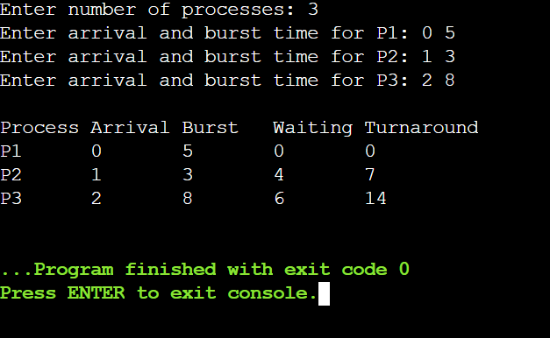

## **Shortest Job First (SJF) Scheduling (Preemptive)**

## **Algorithm Overview**

SJF prioritizes processes with the shortest burst time. The preemptive variant (Shortest Remaining Time First) allows interrupting the current process if a shorter job arrives

#include <iostream>

#include <vector>

#include <algorithm>

#include <climits>

using namespace std;

struct Process {

int id;

int arrivalTime;

int burstTime;

int remainingTime;

int completionTime;

int waitingTime;

int turnaroundTime;

};

void sjfPreemptive(vector<Process>& processes) {

int currentTime = 0;

int completed = 0;

int n = processes.size();

while (completed != n) {

int shortest = -1;

int minRemaining = INT_MAX;

for (int i = 0; i < n; ++i) {

if (processes[i].arrivalTime <= currentTime && processes[i].remainingTime < minRemaining && processes[i].remainingTime > 0) {

shortest = i;

minRemaining = processes[i].remainingTime;

}

}

if (shortest == -1) {

currentTime++;

continue;

}

processes[shortest].remainingTime--;

currentTime++;

if (processes[shortest].remainingTime == 0) {

processes[shortest].completionTime = currentTime;

processes[shortest].turnaroundTime = processes[shortest].completionTime - processes[shortest].arrivalTime;

processes[shortest].waitingTime = processes[shortest].turnaroundTime - processes[shortest].burstTime;

completed++;

}

}

}

int main() {

int n;

cout << "Enter number of processes: ";

cin >> n;

vector<Process> processes(n);

for (int i = 0; i < n; ++i) {

processes[i].id = i + 1;

cout << "Enter arrival and burst time for P" << processes[i].id << ": ";

cin >> processes[i].arrivalTime >> processes[i].burstTime;

processes[i].remainingTime = processes[i].burstTime;

}

sjfPreemptive(processes);

cout << "\nProcess\tArrival\tBurst\tWaiting\tTurnaround\n";

for (const auto& p : processes) {

cout << "P" << p.id << "\t" << p.arrivalTime << "\t" << p.burstTime

<< "\t" << p.waitingTime << "\t" << p.turnaroundTime << endl;

}

return 0;

}

Output:

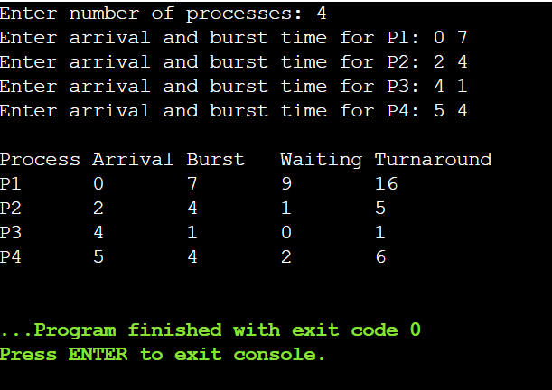

## Round Robin Scheduling

## Algorithm Overview

Round Robin assigns a fixed time quantum to each process, cycling through the ready queue Processes are preempted after the quantum expires and requeued.

#include <iostream>

#include <queue>

#include <vector>

using namespace std;

struct Process {

int id;

int arrivalTime;

int burstTime;

int remainingTime;

int waitingTime;

int turnaroundTime;

};

void roundRobin(vector<Process>& processes, int quantum) {

queue<int> readyQueue;

int currentTime = 0;

int n = processes.size();

vector<int> startTime(n, -1);

int index = 0;

while (index < n || !readyQueue.empty()) {

while (index < n && processes[index].arrivalTime <= currentTime) {

readyQueue.push(index);

index++;

}

if (readyQueue.empty()) {

currentTime++;

continue;

}

int currentIdx = readyQueue.front();

readyQueue.pop();

if (startTime[currentIdx] == -1) {

startTime[currentIdx] = currentTime;

}

int executionTime = min(processes[currentIdx].remainingTime, quantum);

processes[currentIdx].remainingTime -= executionTime;

currentTime += executionTime;

while (index < n && processes[index].arrivalTime <= currentTime) {

readyQueue.push(index);

index++;

}

if (processes[currentIdx].remainingTime > 0) {

readyQueue.push(currentIdx);

} else {

processes[currentIdx].turnaroundTime = currentTime - processes[currentIdx].arrivalTime;

processes[currentIdx].waitingTime = processes[currentIdx].turnaroundTime - processes[currentIdx].burstTime;

}

}

}

int main() {

int n, quantum;

cout << "Enter number of processes: ";

cin >> n;

cout << "Enter time quantum: ";

cin >> quantum;

vector<Process> processes(n);

for (int i = 0; i < n; ++i) {

processes[i].id = i + 1;

cout << "Enter arrival and burst time for P" << processes[i].id << ": ";

cin >> processes[i].arrivalTime >> processes[i].burstTime;

processes[i].remainingTime = processes[i].burstTime;

}

sort(processes.begin(), processes.end(), [](const Process& a, const Process& b) {

return a.arrivalTime < b.arrivalTime;

});

roundRobin(processes, quantum);

cout << "\nProcess\tArrival\tBurst\tWaiting\tTurnaround\n";

for (const auto& p : processes) {

cout << "P" << p.id << "\t" << p.arrivalTime << "\t" << p.burstTime

<< "\t" << p.waitingTime << "\t" << p.turnaroundTime << endl;

}

return 0;

}

Output:

